**Jobsheet-6: JQuery and Bootstrap**

**Web Design and Programming Courses**

Erwan Majid/08/2i

Link github: <https://github.com/Majid5654/Semester-3/tree/master/Week6>

* **Practical Section 1. Preparing to Use JQuery**





* **Practical Section 2. Document Ready Function**

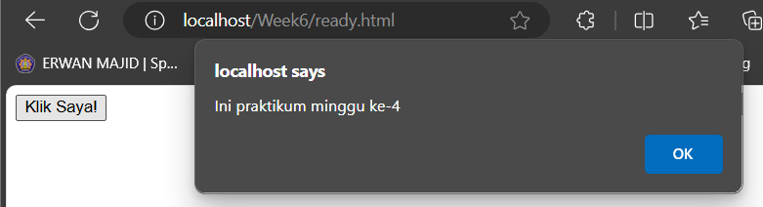

**-**After modified:

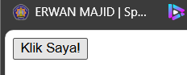

1. From your observations, what do you understand from the document ready() function?

Record the results of your observations and explanations of your understanding below (Question No. 1)

-before modified : code runs after the DOM is fully loaded, ensuring the click event is attached successfully

-After modified: If the script is executed before the DOM element #button1 exists, the event handler won't be attached, leading to no response when the button is clicked

* **Practical Section 3. Selector**

1. Record and explain your observations after running the program code above. (Question No. 2)

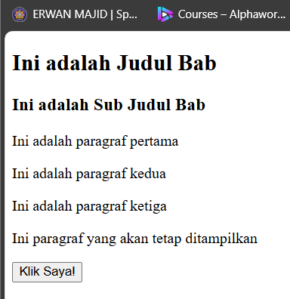

-<h2>: This is a second-level heading element, used for the title of the section ("Ini adalah Judul Bab").

-<h3 class="subjudul">: This is a third-level heading element, which represents a subheading ("Ini adalah Sub Judul Bab"). Additionally, it has a class attribute called "subjudul

-<p id="paragraf">: This is a paragraph element with the id attribute set to "paragraf". The text inside the paragraph is "Ini adalah paragraf pertama".

-A div element groups one of the paragraphs inside.

The document ends with a button element that could be used to trigger events, such as showing an alert or performing some action with JavaScript.

1. In the program code in step number 1, there are some jQuery selector writings. Write down and explain what jQuery Selector is in your code. (Question No. 3)

-$("#id"): Selects an element by id. In your case, $("#paragraf") targets the element with id="paragraf".

-$(".class"): Selects elements by class. For example, $(".dua") targets elements with class="dua", and $(".paragraf") targets all elements with class="paragraf".

-$("tag"): Selects all elements of a particular tag name, like $("p") to select all paragraphs.

-$("element"): Selects specific elements like buttons, images, or inputs (e.g., $("button")).

* **Practical Section 4. Events**

1. Record and describe the changes that occurred based on your observations (Question No.4)

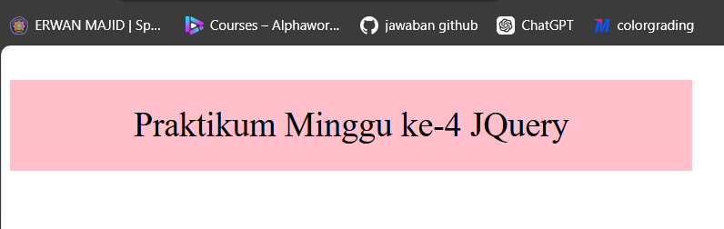

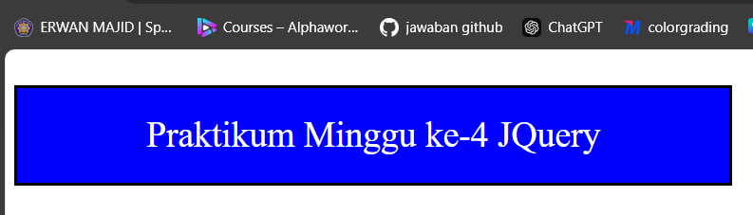-the paragraph with the id="paragraf" is styled with a width of 600px, height of 80px, pink background, centered text, and a font size of 30px

Click: When the user clicks on the element with id="paragraf", the text color changes to white.

Mouseover: When the user hovers the mouse over the element, the background color changes to silver.

Mouseout: When the user moves the mouse out of the element, the background color changes to blue.

Double-click: When the user double-clicks the element, a solid black border (3px) is added around it

-The paragraph with the text "Praktikum Minggu ke-4 JQuery" will display and respond to the events specified in the script.

* **Practical Section 5. Hide and Show Effect**

1. Record and describe the changes that occurred based on your observations (Question No.5)

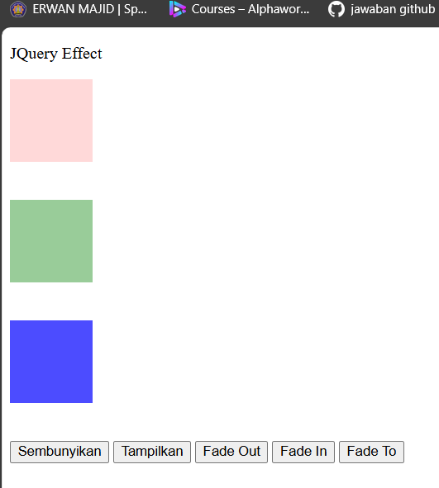

-The HTML includes three <div> elements with IDs div1, div2, and div3. Each of these <div> elements is styled using the .kotak

-The buttons (<button>) are used to trigger various jQuery effects when clicked

-Hide div1: When the button with the class .tombol1 is clicked, the <div> with ID #div1 will be hidden instantly (hide() method

-Show div1: When the button with the class .tombol2 is clicked, the hidden <div> with ID #div1 will be displayed again using the show() method.

-Fade Out div1, div2, and div3: div1 fades out immediately.

div2 fades out more slowly with the "slow" keyword.

div3 takes 3 seconds to fade out (3000 milliseconds).

-Fade In div1, div2, and div3: div1 fades in immediately.

div2 fades in slowly.

div3 fades in over 3 seconds.

-Fade To a Specific Opacity: div1 fades to 15% opacity.

div2 fades to 40% opacity.

div3 fades to 70% opacity.

-Effect Buttons: <button class="tombol1">Sembunyikan</button>: Each button is associated with a class (.tombol1, .tombol2, etc.), and clicking a button triggers the corresponding jQuery function.

* **Practical Section 6. Slide Effect**

1. Record and explain the changes that occurred based on your observations (Question No.6)

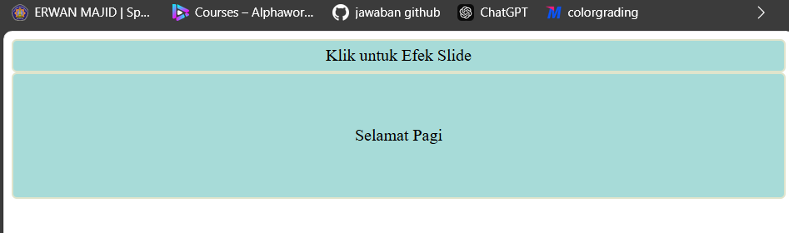

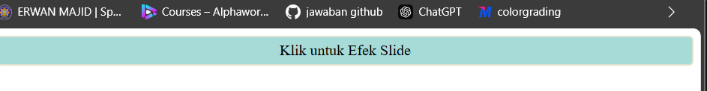

-The jQuery $(document).ready() function ensures that the DOM is fully loaded before running the jQuery code.

-<div id="flip">Klik untuk Efek Slide</div> : A div element with the ID flip. It contains the text "Klik untuk Efek Slide"  
-<div id="kotak2">Selamat Pagi</div> : A div element with the ID kotak2. It contains the text "Selamat Pagi",This is the content that will be affected (slid up) when the flip div is clicked.

-$("#flip").click(function() { ... }); Selects the HTML element with the ID flip (<div id="flip">Klik untuk Efek Slide</div>) and attaches a click event listener to it.

-$("#kotak2").slideUp("slow");slideUp is a jQuery animation effect that hides the selected element by sliding it upwards.

1. Record and describe the changes that occur based on your observations (Question No. 7)

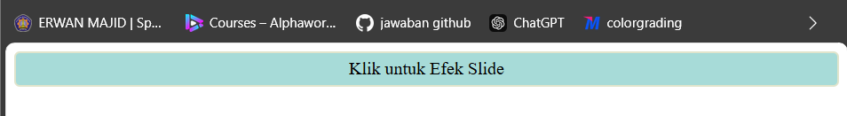

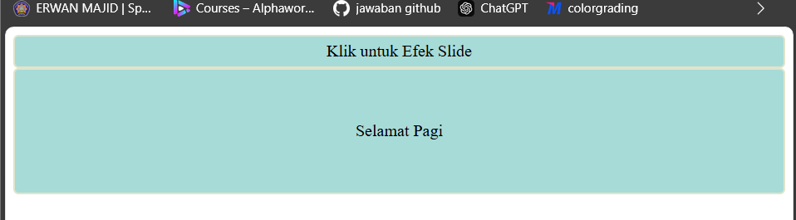

-This code now uses slideDown("slow") to reveal the kotak2 div when the flip div is clicked, which initially is set to display:none; to keep it hidden until the event is triggered.

-$(document).ready(function() { ... });: This is a jQuery function that ensures the code inside it runs only after the HTML document is fully loaded and ready.

-$("#flip").click(function() { ... });: This line attaches a click event handler to the HTML element with the ID flip

-$("#kotak2").slideDown("slow");: This line selects the HTML element with the ID kotak2 and applies a slideDown animation to it with a speed parameter of "slow". This animation smoothly reveals the element by sliding it downwards

-<div id="flip">Klik untuk Efek Slide</div>: This div element has an ID of flip and contains the text "Klik untuk Efek Slide"

-<div id="kotak2" style="display:none;">Selamat Pagi</div>: This div element has an ID of kotak2 and contains the text "Selamat Pagi It is initially hidden from view (style="display:none;") and will only appear when the flip div is clicked.

1. Record and describe the changes that occurred based on your observations (Question No.8)

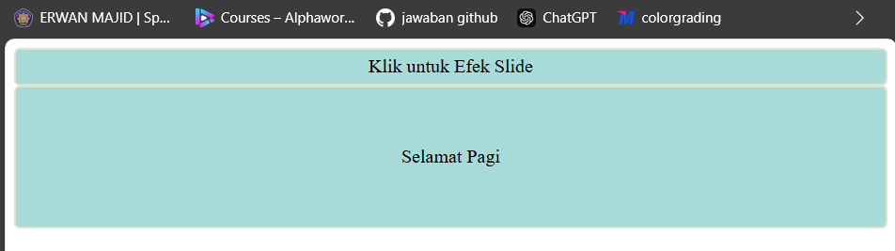

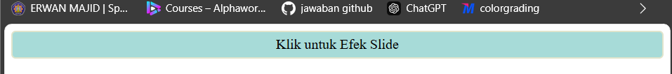

-This code uses slideToggle("slow") to allow the element with the ID kotak2 to smoothly slide up and down when the flip element is clicked

-$("#kotak2").slideToggle("slow");:slideToggle is a jQuery method that toggles the sliding effect, showing the element if it's hidden and hiding it if it's visible.

The "slow" parameter controls the speed of the animation, making it slower and more noticeable.

* **Practical Section 7. Animation**

1. Record and describe the changes that occurred based on your observations (Question No.9)

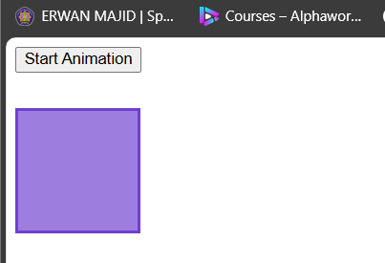

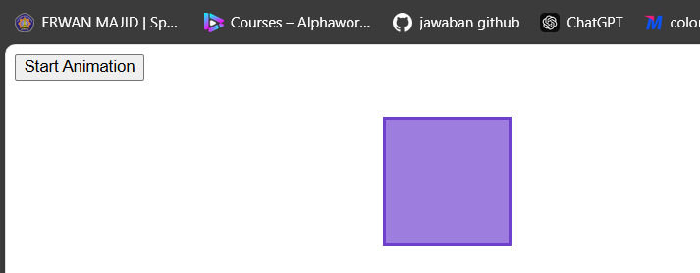

-$(document).ready(function() { ... });:This ensures that the code inside runs only after the HTML document has been fully loaded

-$("button").click(function() { ... });:This line sets up a click event handler for all button elements on the page. When a button is clicked, the function inside is triggered

-$("div").animate({left: 300});:he animate() method gradually changes the CSS properties of the selected element. In this case, it moves the div to the right by setting the left property to 300px.

1. Record and explain the changes that occur based on your observations (Question No. 10)

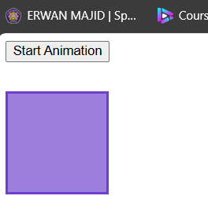

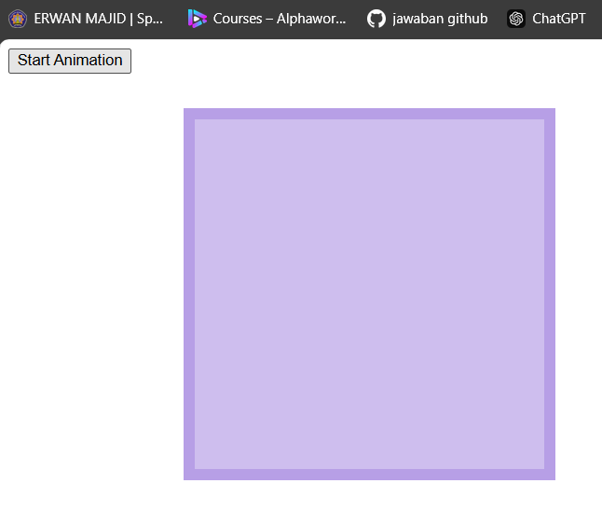

-$(document).ready(function(){:This ensures that the jQuery code only runs after the entire document (HTML content) has fully loaded.

-$("button").click(function(){: This function sets up an event listener on the button. When the button is clicked, the animations are triggered on the .box div element.

-The animate() function is a built-in jQuery function that creates smooth animations for changes in CSS properties

* **Practical Section 8. JQuery DOM Manipulation**

1. Record your observations and explain the differences between the get text(), html(), and val() methods (Question No. 11)

-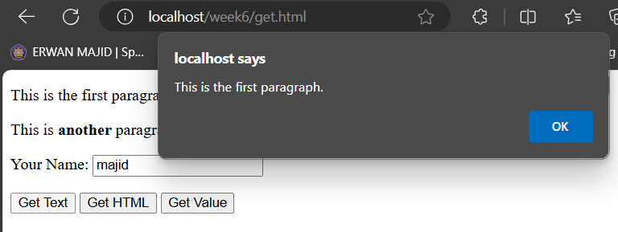

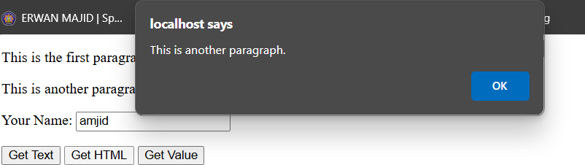

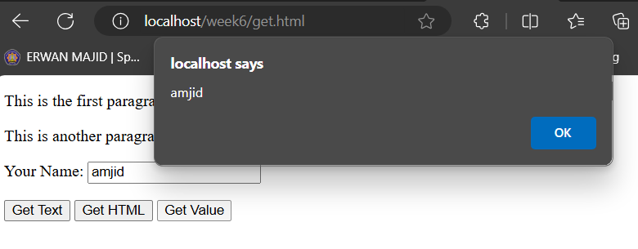

1. Record your observations and explain the differences between the set text(), html(), and val() methods (Question No. 12)

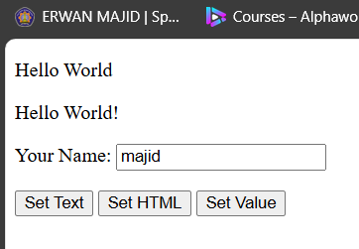

-#btn1: A button labeled "Set Text" that will change the text of the first paragraph.

#btn2: A button labeled "Set HTML" that will change the HTML content of the second paragraph.

#btn3: A button labeled "Set Value" that will change the value inside the input field.

Clicking "Set Text" will update the first paragraph's plain text to "Hello World."

Clicking "Set HTML" will replace the second paragraph's content, including its HTML tags, with "Hello World!".

Clicking "Set Value" will change the value in the text box to "Polinema"

1. Record and explain your observations (Question No. 13)

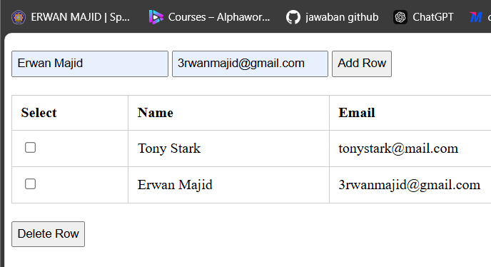

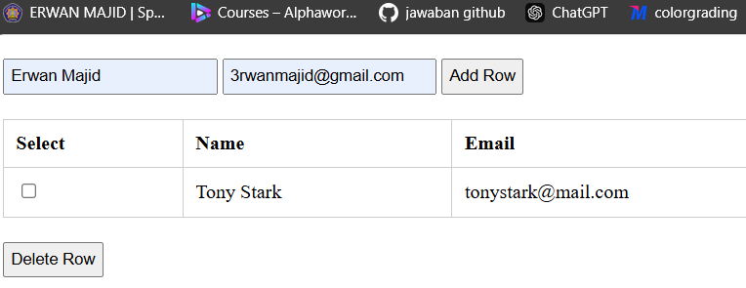

-This code adds a table where you can input a name and email address, then add them as a new row in the table by clicking the "Add Row" button. You can also delete selected rows using the "Delete Row" button

-$(".delete-row").click(): When the "Delete Row" button (with class .delete-row) is clicked, the following actions happen

1. Record and explain your observations (Question No. 14)

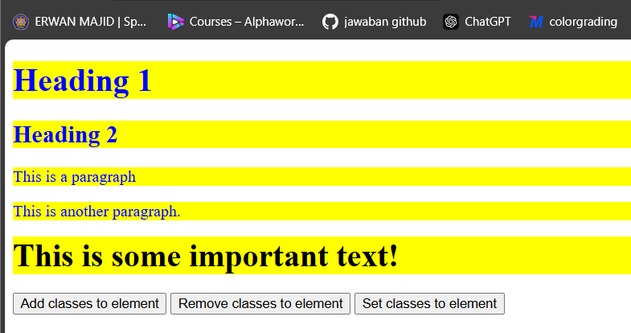

-Button 1 (Add classes to element): When you click this button, The blue class is applied to all <h1>, <h2>, and <p> elements, turning their text blue.

The important class is applied to the <div>, making the text inside bold and setting its font size to xx-large.

-Button 2 : The blue class is removed from all <h1>, <h2>, and <p> elements, meaning their text will no longer be blue

-Button 3: All headings, paragraphs, and the <div> will have a yellow background.

Their font size will be set to 100 pixels.

1. Record and explain your observations (Question No. 15)

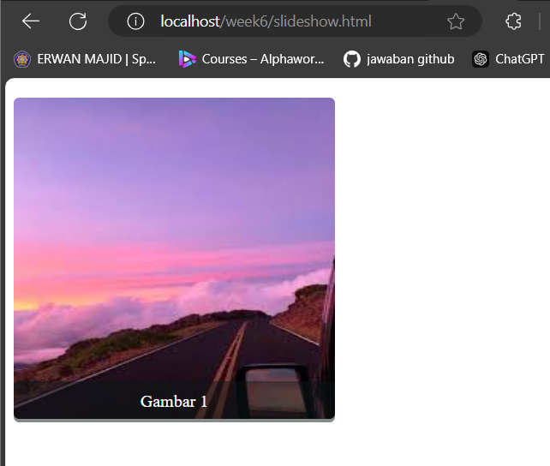

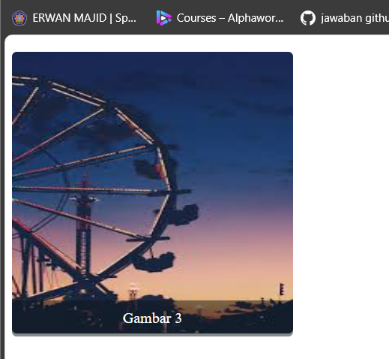

-$('.slidertitle, #slider img').hide();: Hides all the images and titles initially.

-showNextImage();: Calls the showNextImage() function to display the first image and title.

-setInterval('showNextImage()', 3000);: This function runs showNextImage() every 3000 milliseconds (3 seconds) to change the image.

-function showNextImage(): This function handles displaying the next image and title in the slideshow

-$('#sliderImage' + i).appendTo('#slider').fadeIn(1100).delay(1100).fadeOut(1100);:

This selects the image with ID corresponding to the counter i (sliderImage1, sliderImage2, etc.).

-$('#title' + i): Similarly, this handles the title display and fade in/out just like the image.

-if (i == 3) { i = 0; }: Resets the counter i back to 0 when it reaches 3 (since there are 3 images, and they are indexed from 1 to 3).

* **Practical Section 11. JQuery UI Plugin**

1. Record and explain your observations (Question No. 15)

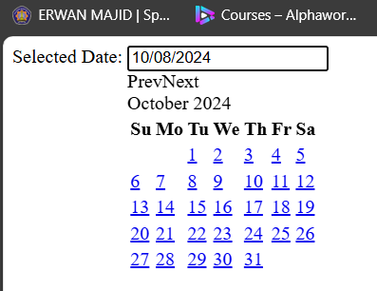

-<script src="jquery-ui-1.14.0.custom/jquery-ui.js"></script>:This line includes the jQuery UI JavaScript file, which provides the date picker widget and other UI components.

-<input type="text" id="date_ex">: This is the text input field where the date picker will be activated. Once the user clicks in the input field, the date picker widget will display, allowing the user to choose a date.

-$("#date_ex").datepicker();: This line applies the datepicker widget to the input field with the ID date_ex. It turns the input field into a date picker, so when the user clicks inside the field, a calendar will pop up to select a date.

1. Record and explain your observations (Question No. 16)

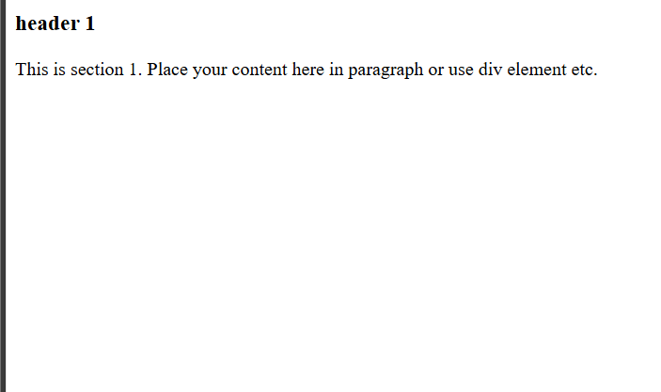

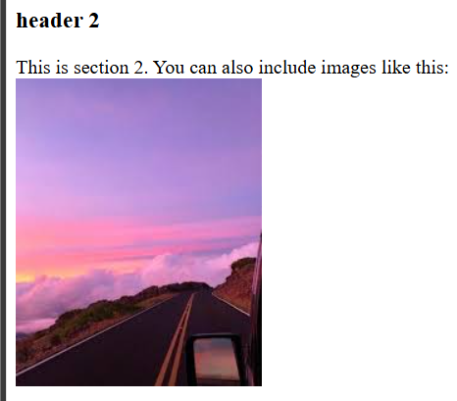

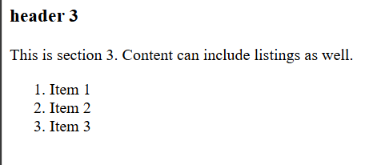

-$( "#jQuery_accordion" ).accordion();: This method initializes the accordion on the div element with the ID jQuery_accordion.

-<div id="jQuery_accordion">: This is the container for the accordion. Inside this div, there are several headers (h3 elements) and content sections (div elements)

-<h3>header 1</h3> and other h3 tags define the headers of each accordion section

-When a user clicks on a header (h3), the corresponding content section (div) slides down, and the other sections collapse (if any are open), maintaining only one section open at a time by default

* **Practical Section 12. JQuery AJAX**

1. Record and explain your observations (Question No. 17)

-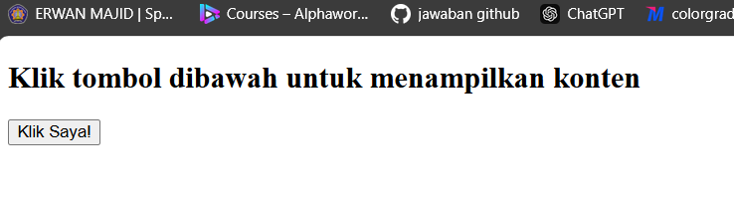

* **Practical Section 12. Getting Started with Bootstrap**

1. Reopen index.html file through the browser. Show the screenshot index.html and also provide the screenshot in step 5. Explain the difference with the result in step 5 (Question No. 17)

-

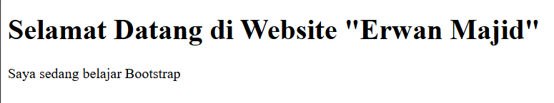

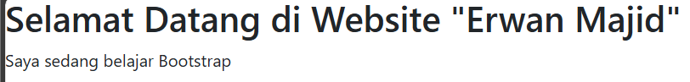

-The difference is font style,which in last version is styling with bootsrap

--Via CDN

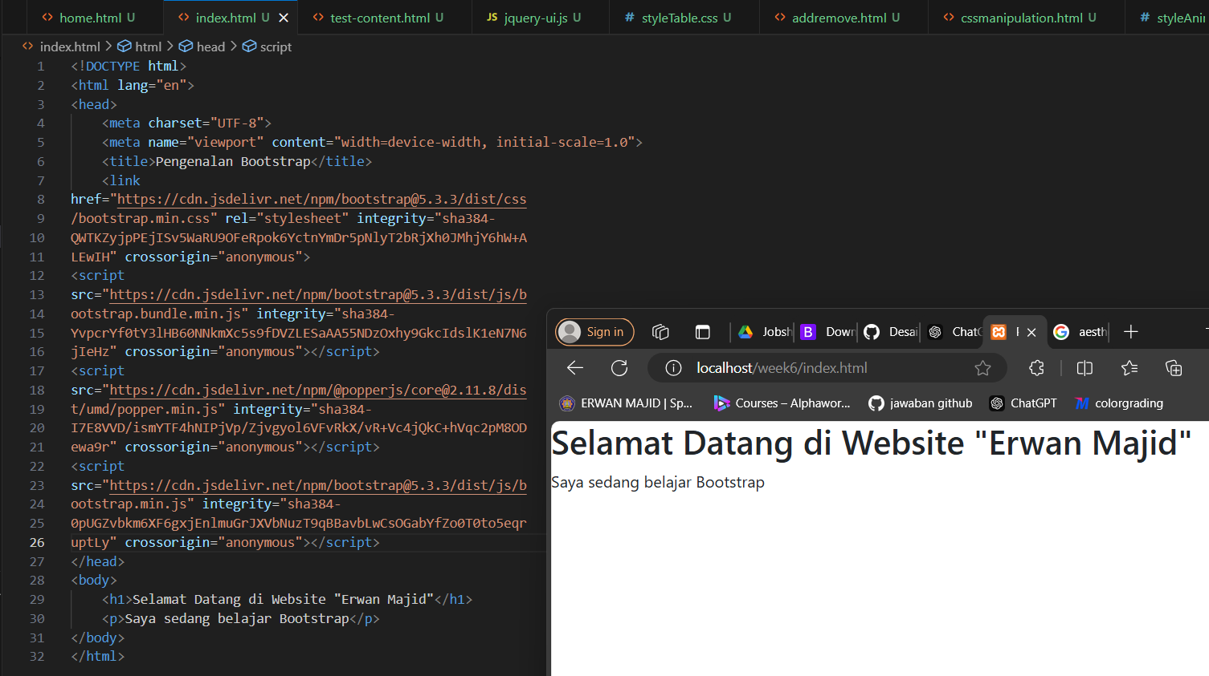

* **Practical Section 13. Container Bootstrap**

1. Run container.html on a browser. Resize the browser to smaller, explain what happened and screenshot the result in the browser (Question No. 18)

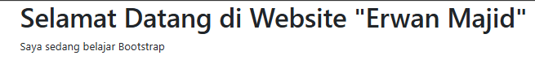

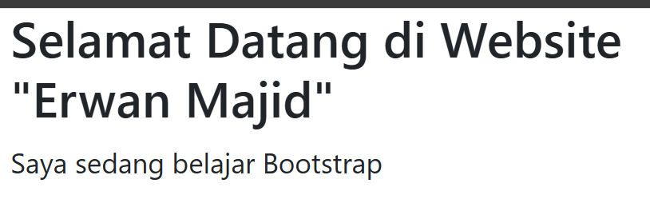

-when zoom out,the text is follow the zoom out,and when zoom in,the text larger

-The .container class in Bootstrap creates a fixed-width container. It has a maximum width at each responsive breakpoint (like small, medium, large screens), meaning it is centered on larger screens and has predefined widths.

For example, on a large screen (lg), the width will max out at 1140px, but on smaller screens, it will automatically adjust to a narrower width (with some margin around the content).

1. Run container.html on a browser. Change the size of the browser to smaller. Screenshot the result in your browser and explain the difference in step 3 (Question No. 19)

-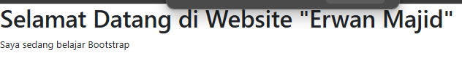

-The container-fluid class is a Bootstrap class that creates a full-width container, spanning the entire width of the viewport. It adjusts the layout automatically, making it responsive across different screen sizes. Unlike .container, which has fixed width breakpoints, .container-fluid is always full width

* **Practical Section 14. Bootstrap Grid System**

1. Run grid.html on a browser. Explain what happened and screenshot the result in the browser (Question No. 20)

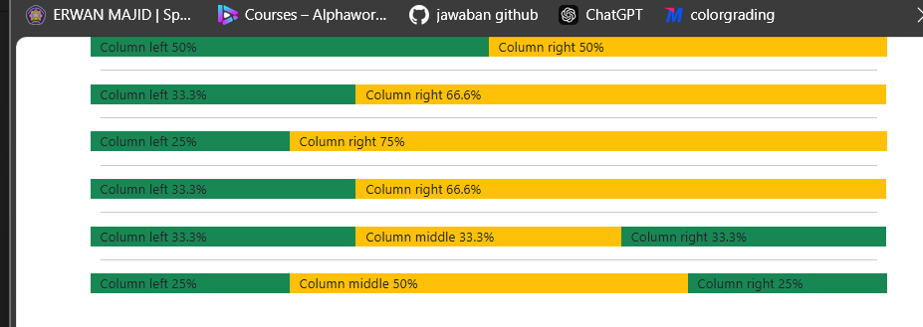

-.container: This Bootstrap class centers the content and gives it a fixed width on large screens. It provides padding around the content and ensures responsiveness.

-.row: A row in the Bootstrap grid system that contains the columns. It is a flexbox container, which allows the columns to be aligned and distributed according to the assigned sizes.

-.col-md-*: The grid column class in Bootstrap, where md stands for the medium breakpoint (768px and above). The number (like 6, 4, 3) specifies how many grid units the column will take. Since the grid has 12 units, col-md-6 means the column will take up half of the row's width (6 out of 12 units).

-Two Equal Columns (50% each): Here, both columns take up half of the row. col-md-6 means each column occupies 6 out of 12 grid units, or 50% of the available space

-One-Third and Two-Thirds Columns (33.3% and 66.6%):The left column takes up 4 units (33.3%) and the right column takes up 8 units (66.6%).

-One-Quarter and Three-Quarters Columns (25% and 75%):The left column takes up 3 units (25%) and the right column takes up 9 units (75%).

-Three Equal Columns (33.3% each): Each of the three columns takes up 4 units, or one-third of the row.

-One-Quarter, Half, and One-Quarter Columns (25%, 50%, 25%):The middle column takes up 6 units (50%), while the left and right columns take 3 units (25%) each.

-.bg-success: This is a Bootstrap class that applies a green background color to the columns.

.bg-warning: This is a Bootstrap class that applies a yellow background color to the columns.

1. Run grid2.html on a browser. Explain what happened and how it differed from step 3, and screenshot the result in the browser (Question No. 21)

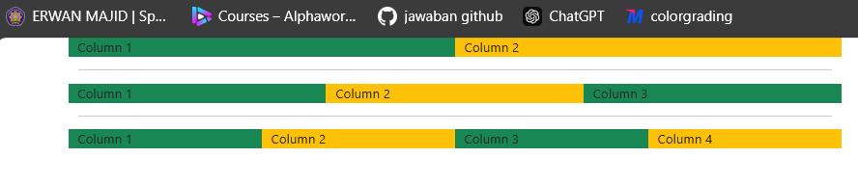

-The content is wrapped inside a Bootstrap container using the <div class="container"> tag. This ensures that the content inside is centered and spaced according to Bootstrap's responsive grid system.

-The container contains several rows (<div class="row">). Each row is a horizontal grouping of columns. Inside each row, the columns are laid out horizontally.

-First Row (2 Columns): This row has two columns. Each column takes up 50% of the row's width, and the bg-success and bg-warning classes from Bootstrap apply the background colors (green and yellow) to the first and second columns, respectively.

-Second Row (3 Columns): In this row, there are three columns. Each column takes up one-third of the row's width, and the background colors alternate between green and yellow.

-Third Row (4 Columns): This row has four columns, each taking up 25% of the total row width. The background colors alternate between green and yellow.

-The use of the .col class tells Bootstrap to distribute the columns evenly across the row. When using .col without specifying a size (like .col-md-6), Bootstrap will automatically assign equal widths to each column in a row, based on how many columns are present.

2 columns → Each column takes 50% of the width.

3 columns → Each column takes 33.33% of the width.

4 columns → Each column takes 25% of the width.

1. Run grid3.html on a browser. Explain what happened and screenshot the result in the browser (Question No. 22)

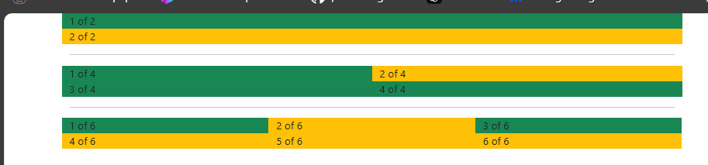

-The .container class is used to wrap the entire content, providing consistent horizontal padding across the screen sizes.

-The .row class defines a row in the grid system, and inside each row, there are columns defined using the .col class.

-The row-cols-* classes specify how many columns should be created per row in a flexible manner, and the number of columns is automatically calculated based on the number specified.

-First Row (row-cols-1): This row uses row-cols-1, which means each column will take up the entire row width (100% width), The bg-success (green background) and bg-warning (yellow background) classes are applied for styling the background color.

-Second Row (row-cols-2): Here, row-cols-2 means each row will contain two columns.

There are four columns in total, so they will be distributed across two rows (each row having two columns). Each column will take up 50% of the row width.

-Third Row (row-cols-3): row-cols-3 means each row will have three columns.

There are six columns in total, so they will be distributed across two rows (each row containing three columns). Each column takes up 33.33% of the row width.

-.row-cols-1, .row-cols-2, and .row-cols-3:These Bootstrap classes define the number of columns that should be placed in each row.

* **Practical Section 15. Table on Bootstrap**

1. Run tabel.html on a browser. Describe your observations and screenshot the results in

your browser (Question No. 23)

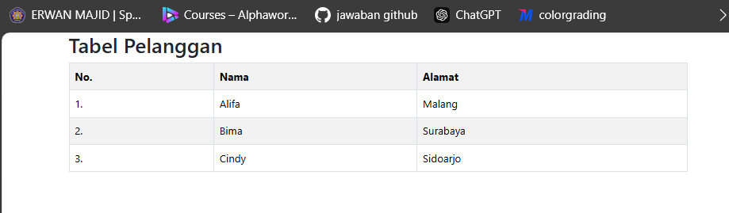

-div class="container">: A Bootstrap class that adds responsive padding and centers the content within the viewport.

<h2>Tabel Pelanggan</h2>: A heading for the table, indicating that it contains customer data.

<table class="table table-bordered table-striped table-hover">: This creates a table with several Bootstrap classes for styling:

table: Applies the default Bootstrap table styling.

table-bordered: Adds borders to the table and its cells.

table-striped: Alternates the background color of table rows for better readability.

table-hover: Changes the background color of table rows when hovered over with the mouse.

Table Rows and Data:

The first row contains table headers defined with <th>, which are bold and centered by default:

* **Practical Section 16. Image Settings in Bootstrap**

1. Run image.html on a browser. Change the size of the browser to smaller. Describe your observations and screenshot the results in your browser (Question No. 24)

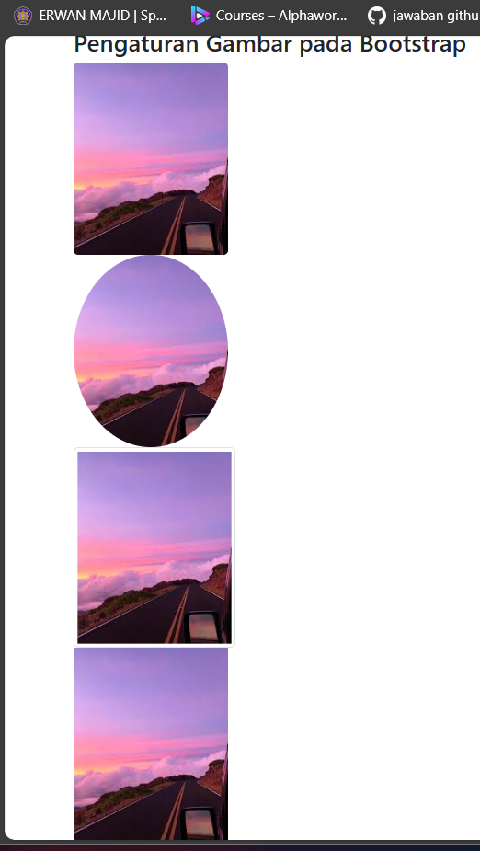

-<div class="container">: A Bootstrap class that provides a responsive fixed-width container for the content, centering it within the viewport.

<h2>Pengaturan Gambar pada Bootstrap</h2>: A heading for the section, indicating that it discusses image settings in Bootstrap.

<div class="row row-cols-1">: Creates a new Bootstrap row. The row-cols-1 class specifies that there will be one column per row in a grid layout.

-First Column: Displays an image with rounded corners using the rounded class.

-Second Column: Displays an image shaped as a circle using the rounded-circle class.

-Third Column: Displays an image with a thumbnail style using the img-thumbnail class, which adds padding and a border around the image.

-Fourth Column: Displays a responsive image that scales with the parent element using the img-fluid class, making it adapt to the width of its container

* **Practical Section 17. Creating a Jumbotron with Bootstrap**

1. Run jumbotron.html on your browser. Describe your observations and screenshot the results

in your browser (Question No. 25)

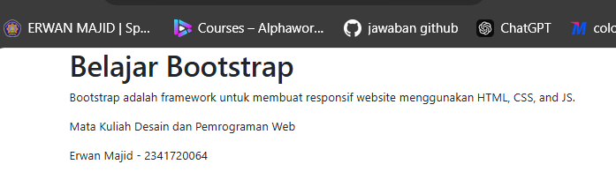

-<div class="container">: This Bootstrap class creates a responsive fixed-width container for the content, centering it within the viewport.

<div class="jumbotron">: This Bootstrap component is used for creating a large, attention-grabbing header or section. It typically includes a heading and some descriptive text.

<h1>Belajar Bootstrap</h1>: This is a main heading within the jumbotron, indicating the subject matter of the page (learning Bootstrap).

<p>Bootstrap adalah framework untuk membuat responsif website menggunakan HTML, CSS, and JS.</p>: A paragraph describing what Bootstrap is and its purpose.

* **Practical Section 18. Creating Alerts with Bootstrap**

1. Run alert.html on your browser. Describe your observations and screenshot the results in your browser (Question No. 26)

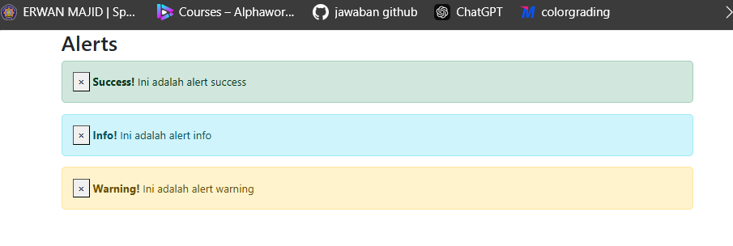

-<div class="container">: Creates a responsive fixed-width container that centers the content within the viewport.

<h2>Alerts</h2>: A heading that indicates the section is about alerts.

Each alert is created using a <div> with the class alert followed by a specific alert type (e.g., alert-success, alert-info, alert-warning).

alert alert-success: Indicates that this is a success alert, styled with Bootstrap's green background.

alert-dismissible: Allows the alert to be dismissed (closed) by the user.

<button type="button" class="close" data-dismiss="alert">&times;</button>: A button to close the alert, with data-dismiss="alert" indicating it should remove the alert from the page when clicked. The &times; character creates an "×" icon.

<strong>Success!</strong>: Bold text to emphasize the alert type.

Ini adalah alert success: The message displayed in the alert.

Info Alert:Structured similarly to the success alert but with the alert-info class, which styles it with a blue background.

Warning Alert:Similar to the previous alerts but uses the alert-warning class for a yellow background.

* **Practical Section 19. Creating a Button with Bootstrap**

1. Run button.html on a browser. Describe your observations and screenshot the results in your browser (Question No. 27)

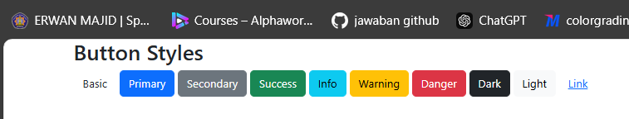

-<div class="container">: Creates a responsive fixed-width container that centers the content within the viewport.

<h2>Button Styles</h2>: A heading that indicates the section is about different button styles.

Basic Button: This creates a basic button without any additional styling

Styled Buttons: btn btn-primary: This class combination applies Bootstrap's primary color styling (typically blue).

-btn btn-secondary: This applies the secondary color (typically gray).

btn btn-success: Styles the button with a green background to indicate success.

btn btn-info: Applies a light blue background for informational messages.

btn btn-warning: Styles the button with a yellow background to indicate a warning.

btn btn-danger: Colors the button red to signify danger or important alerts

btn btn-dark: Styles the button with a dark background.

btn btn-light: Applies a light background to the button.

btn btn-link: Styles the button to look like a hyperlink, typically without a background.

* **Practical Section 20. Creating a Navbar with Bootstrap**

1. Run navbar.html on a browser. Describe your observations and screenshot the results in the

browser (Question No. 28)

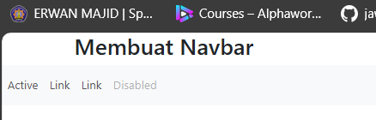

-Container This creates a responsive fixed-width container that centers the content within the viewport. The heading <h2> introduces the topic of creating a navbar

-Navbar Component: The <nav> element defines the navigation bar.

navbar: A class that applies Bootstrap's navbar styles

-Navbar Items: The <ul> element creates an unordered list of navigation links.

Active Link: The active class highlights the currently active link, typically giving it a different style to indicate it is selected.

Normal Links: Standard navigation links with no additional styling

-Disabled Link: The disabled class applies styling to indicate that this link is not clickable

1. Run navbar2.html on a browser. Describe your observations and screenshot the results in your browser (Question No. 29)

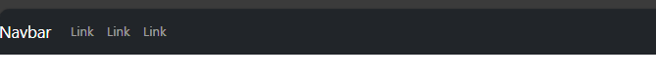

-The <nav> element defines the navigation bar.

navbar: A class that applies Bootstrap's navbar styles.

navbar-expand-md: This class indicates that the navbar will be expandable (collapsible) on medium screens (md) and below. It will remain horizontal on larger screens.

bg-dark: Applies a dark background color to the navbar.

navbar-dark: Indicates that the navbar uses light text colors, which contrast well with the dark background.

-Branding: This <a> element serves as the brand or logo for the navbar. It typically links to the home page. The navbar-brand class styles the brand link appropriately.

Toggler Button: This button appears when the screen size is too small to display the full navbar.

Collapsible Navbar Items: collapse: This class hides the content on smaller screens, which can be toggled by the button.